Contents

Introduction 1

Prerequisites 1

Create a VM from Platform Gallery (Portal) 1

Create VM from Gallery (CLI) 5

Login to the VM 6

# Introduction

The purpose of this document is to show the attendee how to set up an Azure Virtual Machine from the image gallery. In this example, Ubuntu 12.04 LTS is used as operating system.

## Prerequisites

The attendee needs an Azure subscription.

# Create a VM from Platform Gallery (Portal)

Open your web browser, navigate to <https://manage.windowsazure.com> and login with your Azure subscription.

In the bottom left corner, click on “New”:



Choose “Compute”/”Virtual Machine”/”From Gallery” in the Window popping up:

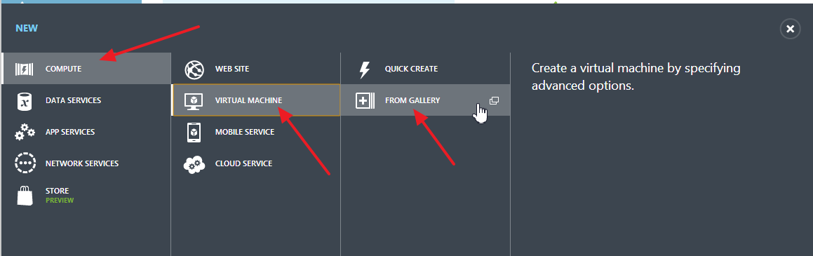

A wizard will pop up. On the first screen of the wizard, you can select your desired image. In this example, you will use Ubuntu 12.04 LTS. Select the appropriate image and then click on “Next”:

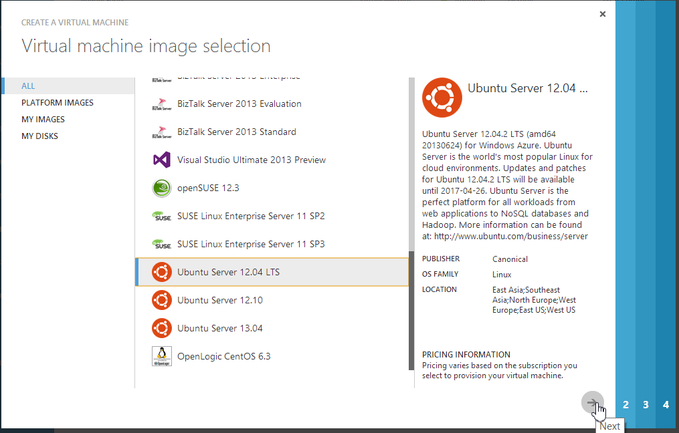

On the next screen, you can configure your virtual machine. You can choose a different release date if you want (defaults to latest). Set the name of your virtual machine, the size (defaults to small) and a username. You can either choose to authenticate with SSH keys, password, or both. In this example, you will authenticate with password, so check the appropriate boxes and provide a password. Then click next:

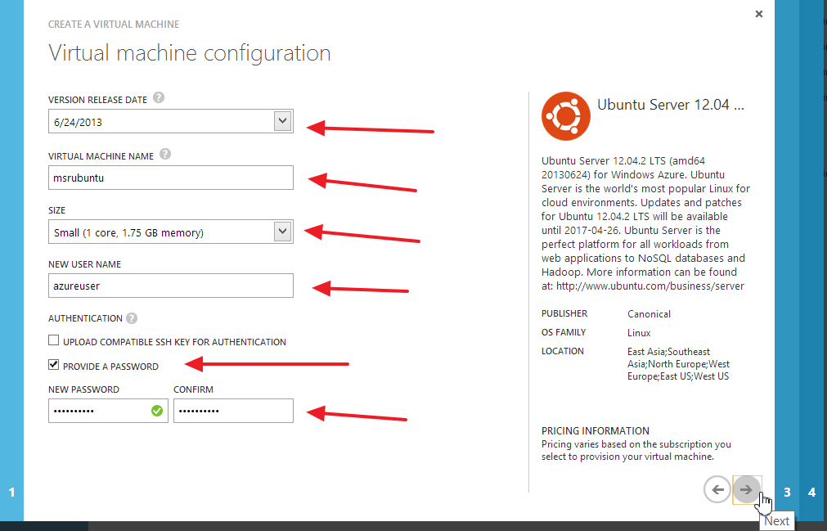

On the last screen of the Wizard, choose to “Create a new cloud service”. If you want to, you can choose a different DNS name for the VM. Choose an appropriate region, select “Use an automatically generated storage account” and select “None” for the availability set. Then click “Next”:

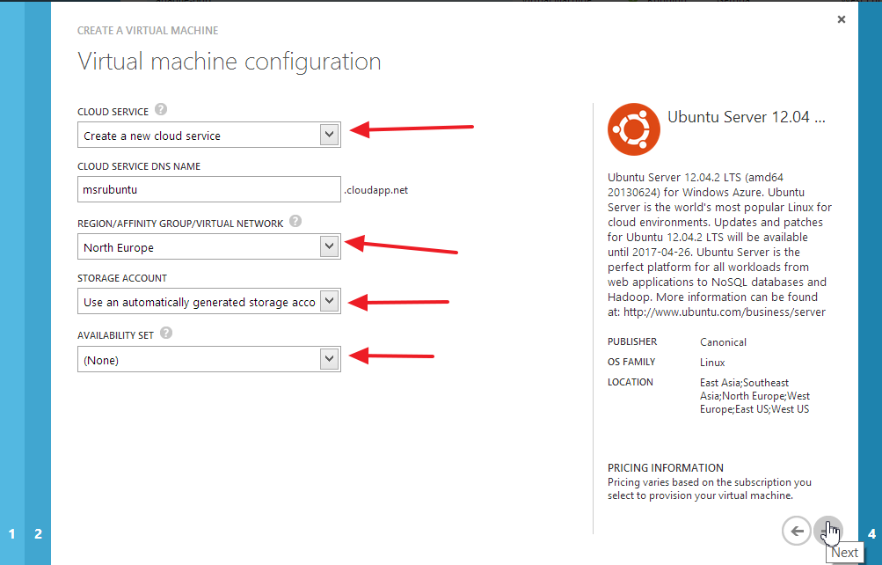

On the last screen, you can configure endpoints for the VM. The Endpoints configuration allows you to make ports available from the outside. In this example, SSH is automatically configured. It will be accessible on <dns-name>:22 from the outside and forward all traffic to the internal SSH server port, which is 22 as well.

You can adapt the endpoint configuration later, so click “Complete” to start the VM provisioning:

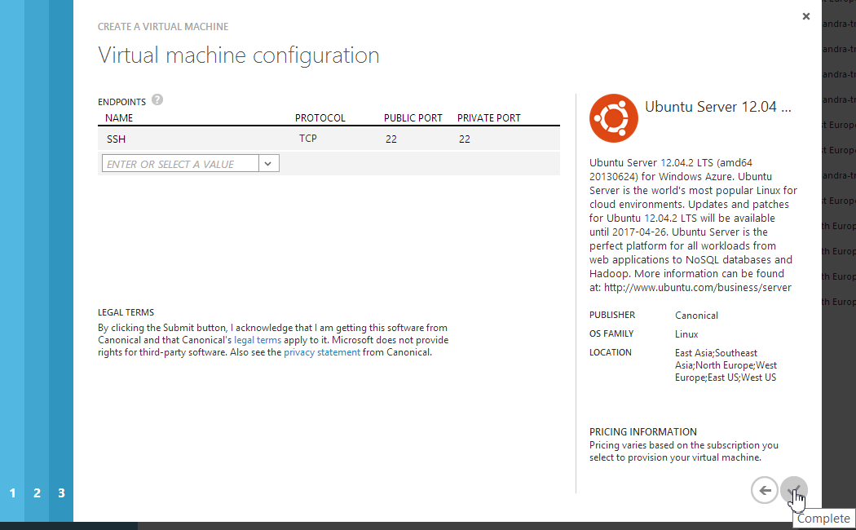

Azure will now create the virtual machine. This will take a couple of minutes. You can track the progress in the bar at the bottom:

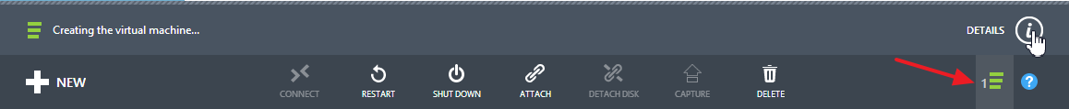

After the virtual machine is created, select “Virtual Machines” in the left-hand bar of the portal. You should see an overview of your virtual machines including the newly created one with status “Running”:

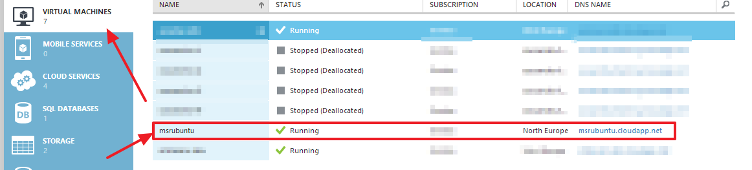

# Create VM from Gallery (CLI)

There is also the possibility to create a virtual machine with a gallery image from the command line. To do this, open up your console.

At the beginning, you should choose the image to use. You can get a list of available images with the command

azure vm image list

This command will list all the available images. In this example, you will use the latest Ubuntu 12.04 LTS release called

b39f27a8b8c64d52b05eac6a62ebad85__Ubuntu-12_04_2-LTS-amd64-server-20130624-en-us-30GB

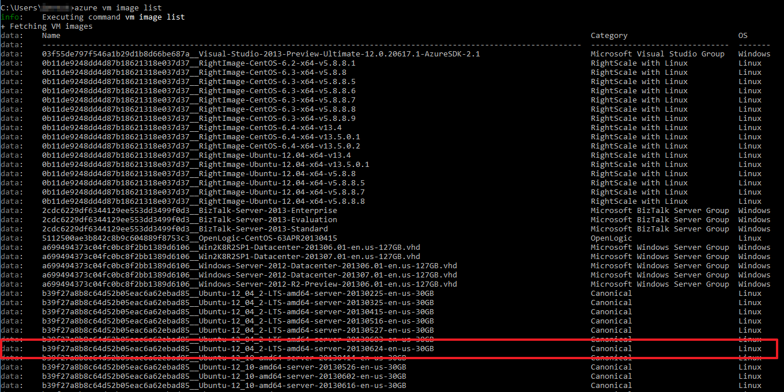

VMs can be created in different locations. To get a list of locations, you can use the command

azure vm location list

Choose a location that is geographically near to your workplace:

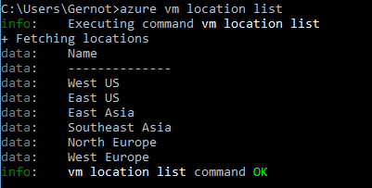

With the name of the image and the location you can create a new VM. The command for this is:

azure vm create <vm-name> <image-name> <username> --location <location> --ssh

The --ssh flag enables ssh (defaults on port 22). For Windows VMs, you can enable RDP instead with the --rdp flag.

Replace “vm-name” with a name of your liking (this will also be the DNS name), use the image name from above as “image-name” and select the “username” you want to use to login to the VM. For the location, remember to use double quotes as it contains spaces.

During creation of the VM, you will be prompted for a password.

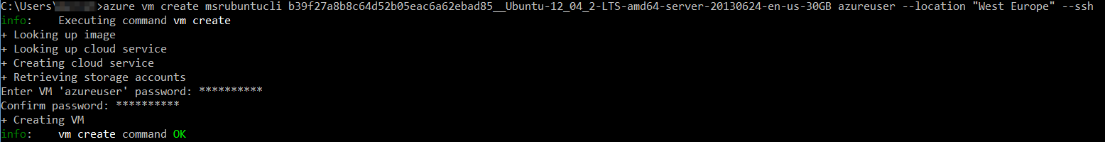

This step will take a few minutes.

# Login to the VM

No matter if you created the VM from the portal or the CLI, you can login to it using SSH using host name <dns-name>.cloudapp.net and port 22. On Windows, you can use for example Putty to connect to it:

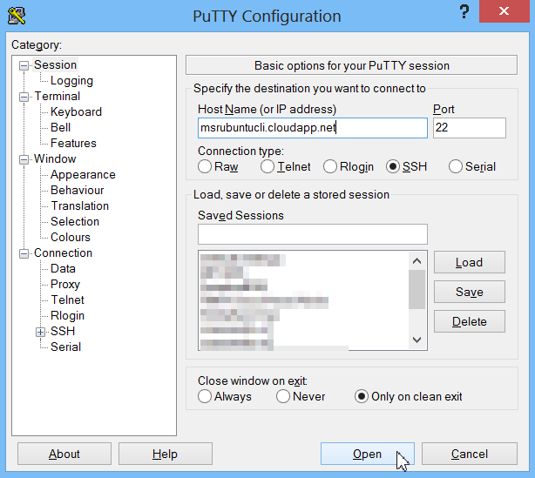

Of course, you can use a command line client as well:

ssh <username>@<dns-name>.cloudapp.net

